**CSIS 2270:**

**Slide 04: Internet Protocol Addressing and Subnetting**

**Internet Protocol Version (IPv4):**

* A network administrator uses the Transmission Control Protocol (TCP) and the Internet protocol (IP).
* IPv4 is a version of IP’s. It’s still the most frequent protocol that resides on the network layer of the OSI model.

**IP Addresses:**

* An IP address has four decimal numbers, each slot is an 8bit word, with a value between 0 and 255.
* Examples:
  + 192.168.0.1.
  + 184.57.10.101.
* Every IP address is seen by the computer in the binary form.
* An IP address is formed by a ***Network ID*** and a ***Host ID***.
* A ***subnet mask*** is used to identify the number of bits used for the ***network ID***.
* To connect to the internet, you will also need a ***gateway*** address and a ***DNS server*** address.
  + The ***gateway*** address refers to the ***router*** that a device is connected to.

**Binary – Decimal Conversion:**

* Binary numbers are represented as a logical 0 or logical 1 in base 2 format.
  + Each number has a place value of $2^{n}$ where n is the position of the binary digit.
  + When n equals 0, it is known as the Least Significant Bit (LSB).
  + When n equals the most left position on a binary number, it’s known as Most Significant Bit (MSB).

Ample:

**Decimal – Binary Conversion:**

* Algorithm to convert Decimal to Binary:

1. Divide the decimal number by 2, record the remainder of 0 or 1.
2. Divide the quotient by 2 and record the remainder of 0 or 1.
3. Repeat steps 1 to 2 until the quotient is 0.
4. Write the number in reverse order.

**Hexadecimal Numbers:**

* Hexadecimal numbers (HEX) are base 16 numbers.
* One hexadecimal number requires four binary ones to be represented.
* Hexadecimal numbers are: 0 – 9, A, B, C, D, E, F.

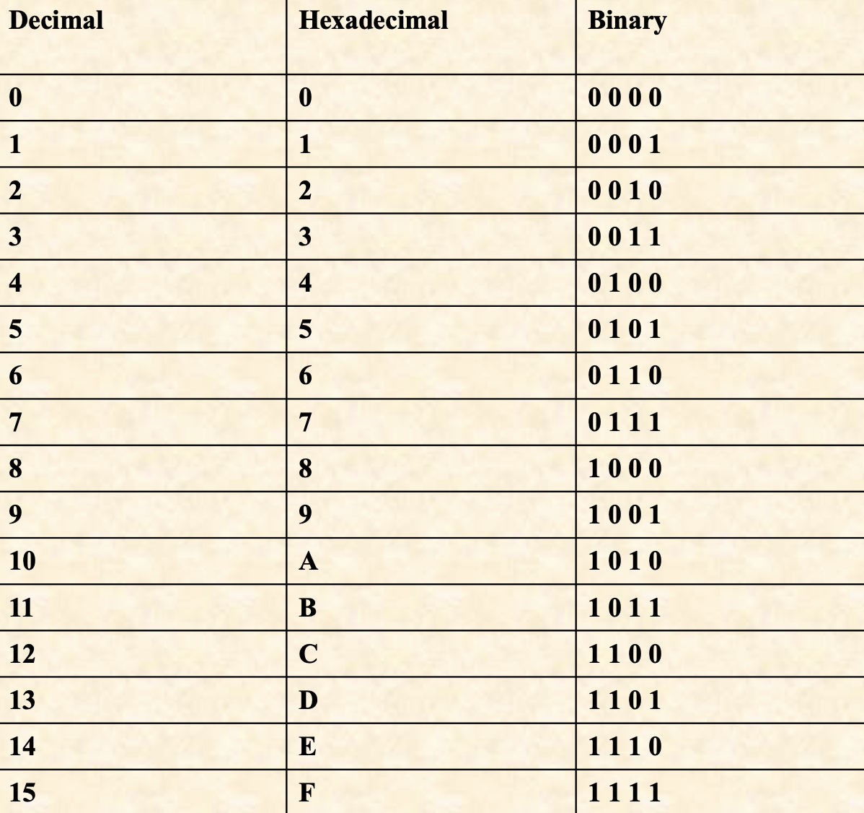

**Classful Network Architecture:**

* The IPv4 classification system is known as the classful network architecture and Is broken down into five classes, three of which are commonly used by hosts on networks – Classes A, B, and C.
* The term ***node*** is synonymous with ***host***.
* If an IP address is Class A, the ***first octet*** is the ***network portion***.



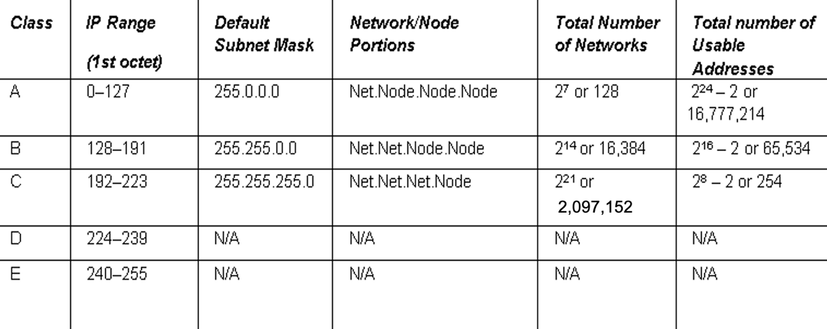

**Network ID and Host ID:**

* Separating network ID and host ID.



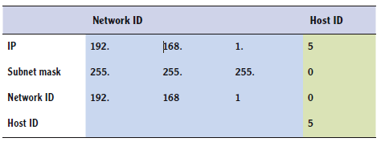

**Loopback Testing:**

* The range of Class A is 0 – 127.
* The 127 network number isn’t used by hosts as a ***logical IP address***. Instead, this network is used for ***loopback IP addresses***, which allow for testing.
  + Example: ping 127.0.0.1.

**Usable Addresses:**

* Usable addresses are always going to be two less than the mathematical account.
* The first and last addresses can’t be used.
  + The 0’s for the host bits defines the entire network.
    - 172.24.0.0 (the net id from a class B network).
  + The 1’s defines the known as the ***broadcast address***.
    - 172.24.255.255 (broadcast a message in the network 172.24.0.0).

**Class D and E:**

* Class D and E are not used by regular hosts.
  + Class D is used for what is known as ***multicasting*** – transmitting data to multiple computers.
    - All computers belonging to a ***multicast group***.
  + Class E was reserved for future use, but this has given way to IPv6 instead.

**IP Conflict:**

* Furthermore, it is important to avoid an ***IP conflict***.
* IP conflicts occur when two computers are configured with the same IP address.

**Public and Private Address:**

* IPv4 address are further classified as either public or private. ***Public IP addresses*** are ones that are exposed to the Internet.
  + Any other computers on the Internet can potentially communicate with them.
* ***Private IP addresses*** are hidden from the Internet and any other networks.
  + They are usually behind an IP proxy or firewall device.
  + Intended to be used on internal networks called.
  + These are called ***non-routable*** IP addresses.

**Private IP Addresses and NAT:**

Class A – 10.0.0.0 to 10.255.255.255.

Class B – 172.16.0.0 to 172.31.255.255.

Class C – 192.168.0.0 to 192.168.255.255.

These address type must be translated by a ***Network Address Translation (NAT***) process on a server or router to Public IP addresses for Internet access.

**Automatic Private IP Addressing (APIPA):**

* It uses a single Class B network number: 169.254.0.0.
  + IP addresses range is from 169.254.0.1 through 169.254.255.254.
* If a Windows client cannot get an IP address from a DHCP server and has not been configured statically, it will auto-assign a number on this network.

**Static and Dynamic Address:**

* Static IP addresses are addresses that are manually assigned as a host.
* Dynamic IP addresses are more common than static IP addresses, whereas they automatically obtain an IP address (and other IP information) from a ***DHCP server***.

**Dynamic Host Configuration Protocol (DHCP)**

* This protocol allows properly configured client computers to obtain IP addresses automatically from a DHCP server.
* The IP information obtained might include the following.
  + IP addresses.
  + Subnet masks.
  + Gateway addresses.
  + DNS server addresses.
  + Other advanced options.

**DORA**

* DHCP sessions use a four-step process known as DORA.
  + **Discovery:** the client computer broadcasts out to the network to find a DHCP server.
  + **Offering:** the DHCP server sends out a unicast offering of an IP address to the client computer.
  + **Request:** the client broadcasts to all servers that it has accepted the offer.
  + **Acknowledge:** the DHCP server sends a final unicast to the client that includes the IP information the client will use.
* Ports 67 and 68.

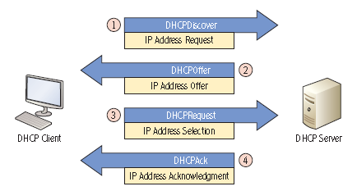

**DHCP Server:**

* DHCP servers can be installed on routers or Windows Servers.
* Installing a DHCP server on Windows Server consists of the following actions:
  + Install the DHCP service.
  + Configuring an IP scope.
  + Activating the scope.
  + Authorizing the server.
  + Configuring advanced IP option (this step is optional).

**Default Gateway and DNS Server**

* To have a fully functional computer, however, we also need to configure two more fields.
  + **Default Gateway:** the first IP address of the device that a client computer will look for when attempting to gain access outside the local network.
  + **DNS Server:** the server that provides name resolution of host names to IP address.
* Default Gateway and DNS Server

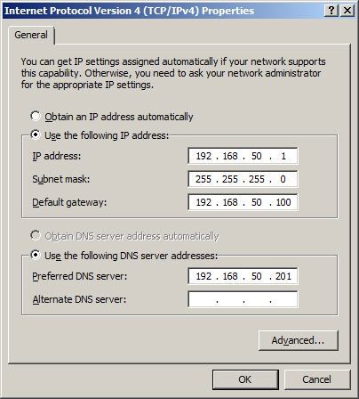

**Exploring the Components of an IPv4 address:**

* Determining local and remotes addresses.

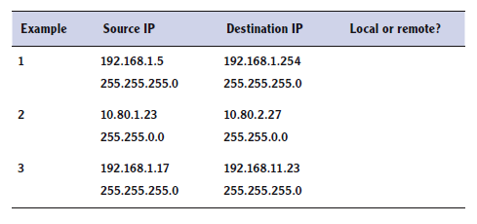

**Network Address Translation (NAT):**

* The process of modifying an IP address, or similar device.
* Private larger address space can be re-mapped to a single public IP address.
* Modern routers allow for Port Address Translation (PAT), a subset of NAT, which translates both IP addresses and port numbers.

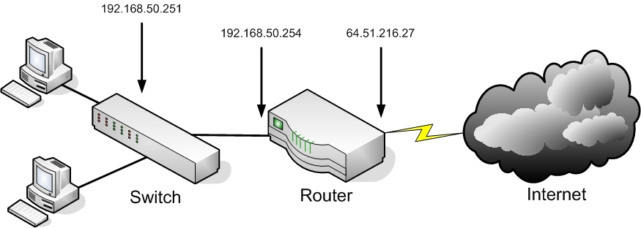

**Subnetting:**

* Subnetting is a technique used to break down (or partition) a network into smaller sub-networks, or subnets.
  + The subnets are created using subnet masks.
* The ***subnet mask*** identifies what bits in the IP address are to be used to represent the network/subnet portion of an IP address.
* The subnets are created by borrowing bits from the host portion of the IP address.
* The network portion of the IP address and the new subnet. Routers use this information to properly forward data packets to the proper subnet.

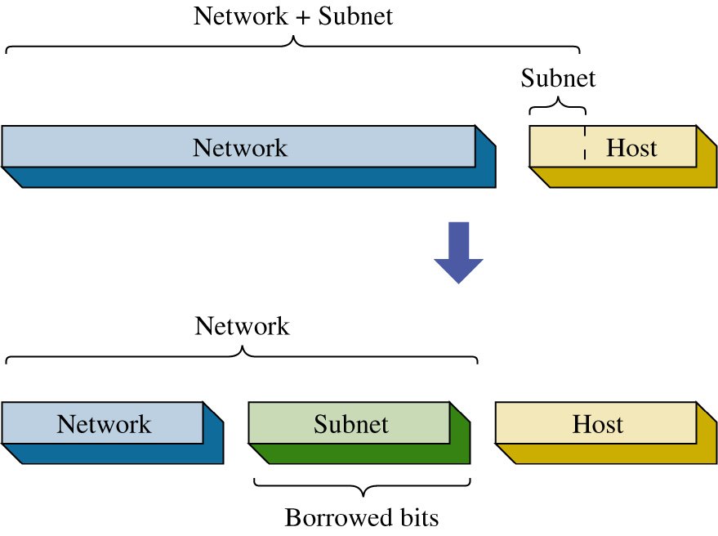

* A class C network is partitioned into four subnets It takes 2 bits to provide four possible subnets. Therefore, 2bits are borrowed from the host bits.
* This means the process of creating the four subnets reduces the number of bits available for host IP addresses.

**ALGORITHM:**

|  |  |  |  |  |  |  |  |  |  |
| --- | --- | --- | --- | --- | --- | --- | --- | --- | --- |
| Subnet | 1 | 2 | 4 | 8 | 16 | 32 | 64 | 128 | 256 |
| Host | 256 | 128 | 64 | 32 | 16 | 8 | 4 | 2 | 1 |
| Subnet Mask | /24 | /25 | /26 | /27 | /28 | /29 | /30 | /31 | /32 |

1. Classify the IP Class.
2. Choose the number of subnets requested by the problem. If the number is somewhat in between the options, choose the first option above it.
3. The column of subnet number chose by step 01, will give you the number of hosts and subnet masks.
4. Create the table with the answers
   1. Network ID = the original + the number of hosts per subnet.
   2. # of usable IDs = number of hosts – network ID – Broadcast ID.
   3. Subnet mask is the same for every one of them.
   4. Broadcast ID = next Network ID – 1.

|  |  |  |  |  |
| --- | --- | --- | --- | --- |
| Network ID | Subnet Mask | Host ID Range | # of usable IDs | Broadcast ID |
|  |  |  |  |  |

Example:

Given a network address of 10.0.0.0, divide the network into 8 subnets. Specify the subnet mask, the number of usable hosts/subnets.

|  |  |  |  |  |  |  |  |  |  |
| --- | --- | --- | --- | --- | --- | --- | --- | --- | --- |
| Subnet | 1 | 2 | 4 | 8 | 16 | 32 | 64 | 128 | 256 |
| Host | 256 | 128 | 64 | 32 | 16 | 8 | 4 | 2 | 1 |
| Subnet Mask | /24 | /25 | /26 | /27 | /28 | /29 | /30 | /31 | /32 |

1. Class A
2. 8 subnets.
3. Therefore, we can have 32 hosts and our subnet mask should be /27.
4. Create the table with the answers

|  |  |  |  |  |
| --- | --- | --- | --- | --- |
| Network ID | Subnet Mask | Host ID Range | # of usable IDs | Broadcast ID |
| 10.0.0.0 | /27 | 0-30 | 32 | 10.31.0.0 |
| 10.32.0.0 | /27 | 32-62 | 32 | 10.63.0.0 |
| 10.64.0.0 | /27 | 64-94 | 32 | 10.95.0.0 |
| 10.96.0.0 | /27 | 96-126 | 32 | 10.127.0.0 |
| 10.128.0.0 | /27 | 128-158 | 32 | 10.159.0.0 |
| 10.160.0.0 | /27 | 160-190 | 32 | 10.191.0.0 |
| 10.192.0.0 | /27 | 192-222 | 32 | 10.223.0.0 |
| 10.224.0.0 | /27 | 224-254 | 32 | 10.255.0.0 |

The subnet mask for creating the 8 subnets will be: 255.224.0.0.

**Subnet Mask:**

* Computer’s use the subnet mask to control data flow within networks.
* The subnet mask is used to determine if the destination IP address is intended for a host in the same LAN or if the data packet should be sent to the gateway IP address of the LAN.
* The gateway IP address is typically the physical network interface on a layer 3 switch or a router.
* Ex.: If a computer as an IP address of 172.16.35.3, and the network as a subnet mask 255.255.255.0.
  + Then, the IP addresses range is from 172.16.35.0 - 172.16.35.255.
  + ***ANDing*** the subnet mask with the destination address, you can find the ***destination network***.

172.16.35.28 AND 255.255.255.0 = 172.16.35.0

172.16.34.15 AND 255.255.255.0 = 172.16.34.0

Different networks.

**Classless Inter-Domain Routing (CIDR):**

* Classful address has a problem of not fully utilizing all addresses available.
  + E.g. a class B address allows $2^{16}-2=65534$.
* CIDR is based on variable-length subnet masking (VLSM).
* CIDR specifies an IP address range using combination of an IP address and its associated network mask.
* xxx.xxx.xxx.xxx/n, where n is the left most ‘1’ bits in the mask.
* Ex.: 192.168.12.0/23
  + Applies the network mask 255.255.255.254.0 to the 192.168 network, starting

at 192.168.12.0.

* + Range 192.168.12.1 – 192.168.13.254 (the first address is the network address, and the last one is the broadcast address).

**Subnetting IPv4:**

* Creating subnets:





**IPv6:**

* IPv6 is the new generation of IP addressing for the Internet, but it can also be used in small office networks and home networks.
* It was designed to overcome the limitations of IPv4, including address space and security.
* IPv6 is a 128-bit system, whereas its still-dominant predecessor IPv4 is only a 32-bit system.
  + IPv4 can support approximately 4 billion addresses.
  + IPv6 can have around 340 undecillion addresses.
* Provides unicast, multicast and anycast addressing.
* Unicast addressing is broken down into three parts:
  + Global routing prefix: 48 bits defines the network.
  + IPv6 subnet defines the individual subnet of the network that the address is located on.
  + Interface ID is the individual host IP portion. It can be assigned to one interface or more than one interface, depending on the type of IPv6 address.
* Written in hexadecimal instead of dotted decimal.

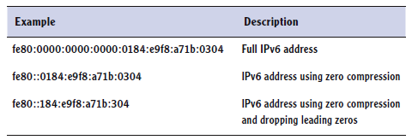

**Virtual LAN (VLAN):**

* Recall: A switch is used to interconnect devices belonging to the same LAN.
* A switch can also be configured with VLANs where a group of computers are configured as if they are in the same LAN even if they reside across routers in separate LANs in different physical locations.

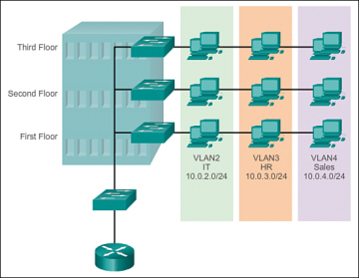

* Advantage: computers and servers can be grouped in the same VLAN based on the organizational group, even if they are not located physically on the same segment or even building.
* Reasons for using VLANs:
  + Separating groups of users who need special security or network functions.
  + Isolating connections with heavy or unpredictable traffic patterns.
  + Identifying groups of devices whose data should be given priority handling.
  + Containing groups of devices that rely on legacy protocols incompatible with most of the network’s traffic.
  + Separating a large network into smaller subnets.
* To create a VLAN:
  + You need a programmable physical switch whose ports can be partitioned into groups.
  + Each VLAN is assigned its own subnet of IP addresses. (Each VLAN and subnet normally is a broadcast domain)
  + A VLAN can include ports from more than one switch.
  + 802.1Q
    - IEEE standard that specifies how VLAN information appears in frames and how switches interpret that information.
* Generalities:
  + There are three types of VLANs: ***port-based***, ***tag-based***, and ***protocol-based***.
  + Port-based: the host computers connected to specific ports on a switch are assigned to a specific VLAN.
  + Tag-based: a tag is added to the Ethernet frames, and it contains the VLAN ID that is used to identify that a frame belongs to a specific VLAN. (Based on the 802.1Q and used for trunking)
  + Protocol-based: data traffic is connected to specific ports based on the type of protocol being used.

**Trunking:**

* Trunk is a single physical connection between switches through which many logical VLANs can transmit and receive data.
* A port on a switch is configured as either an access port or a trunk port
  + Access port – used for connecting a single node (e.g., a PC).
  + Trunk port – capable of managing traffic among multiple VLANs.

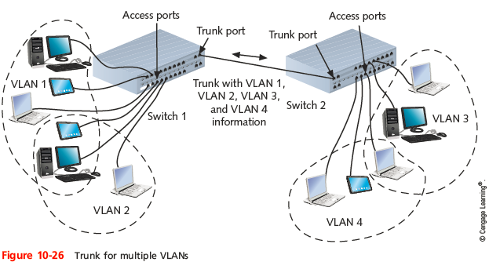

**VLANs and Trunking:**

* To keep data belonging to each VLAN separate, each frame is identified with a VLAN identifier or tag according to 802.1Q.
* Potential problem in crating VLANs is by grouping certain nodes, you are excluding another group.
* To allow different VLANs to exchange data it needs to be connected with a router.

**Slide 05: TCP/IP and Packet Delivery Processes**

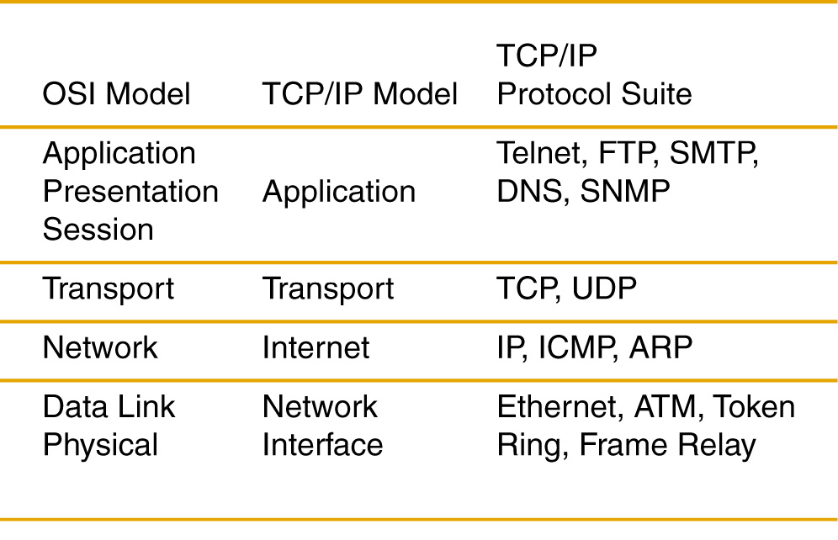

**Understanding Data and PDUs:**

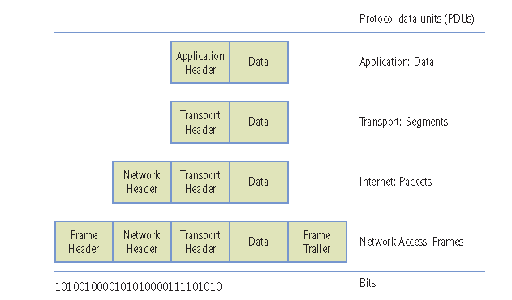

**TCP/IP Encapsulation Process:**

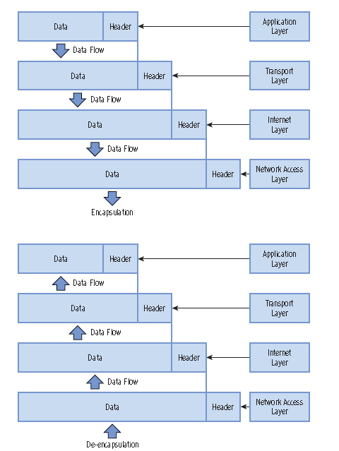

**Transport Layer:**

* Manage the delivery of data between a source and destination host.
* TCP
  + Connection-oriented.
  + Guaranteed Delivery (reliable service).
  + Stateful.
  + Email, file transfer, web browsing.
* UDP
  + Connection-less.
  + Nonguaranteed Delivery (unreliable service).
    - Uses the ***best-effort*** delivery.
  + Stateless.
  + Video Streaming, voice call (skype, zoom).

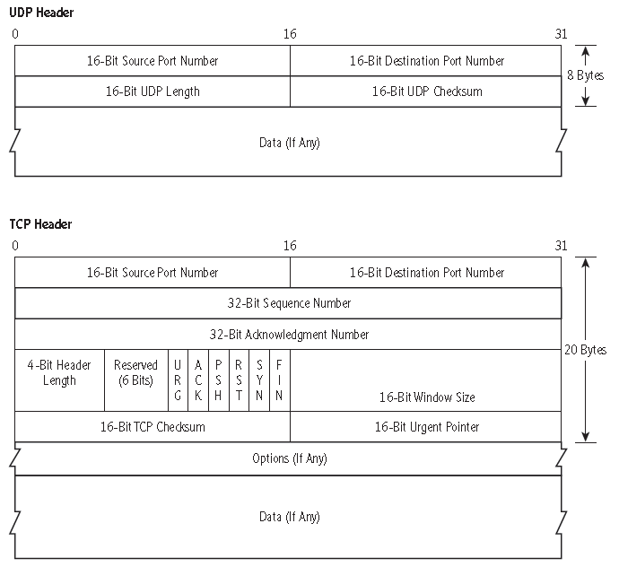

**TCP 3 Way Handshake:**

* Before data is exchange, a connection needs to be setup.
* Legend: ***Syn*** = Synchronizing.

***Ack*** = Acknowledgement.

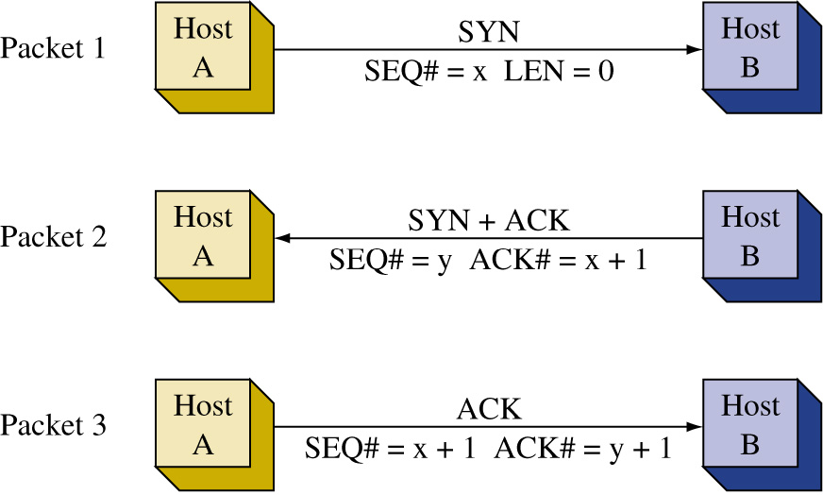

* The connection also needs to be closed when data transmission is completed by using FIN/ACK.
* TCP provides:
  + Sequencing.
  + Acknowledgments.
  + Windowing.
  + Flow Control.

**Understanding Ports:**

* TCP and UDP use port numbers to identify applications.
* Computers listen on specific ports for requests to applications.



* Assigned by IANA.

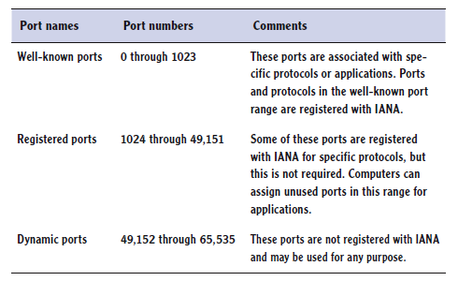

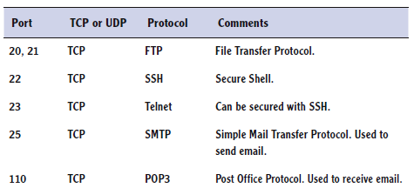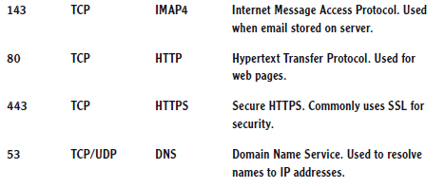

**Internet Layer:**

* Defines the protocols used for address and routing the data packets.
  + Logical addressing.
  + Routing.
  + Packet forwarding.
* Protocols examples:
  + IP
  + ARP
  + ICMP
  + IGMP

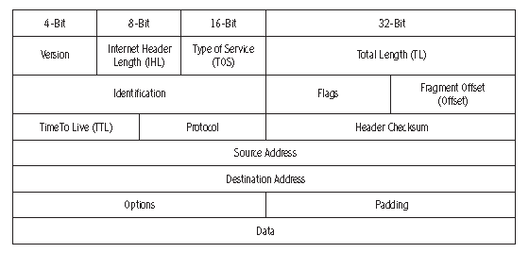

**Address Resolution Protocol (ARP):**

* ARP is used to resolve the IP address to a hardware address (MAC address) for final delivery of data packets to the destination.
* It broadcasts a query in a network called ***ARP request***, asking which network interface has the IP address.
  + The host having the IP address replies with an ***ARP reply*** that contains the hardware address for the destination host.
  + When an ***ARP request*** is issued on the LAN:
    - The destination address is BROADCAST, i.e., this message is being sent to all computers in the local area network.
    - The ARP request message also contains the source IP address, source MAC address, and the destination IP address.

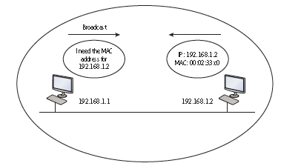

* (IP address, MAC address) pairs are stored in the ***arp cache*** of the local machine for future use if the destination IP address is referenced again.
* To show contents of ARP cache on your PC
  + arp -a
  + arp -d (CAUTION: this one is used to delete the arp cache)

**Packet Delivery Process for Locally Connected Hosts:**

Step 01:



Step 02:



Step 03:



Step 04:



Step 05:



Step 06:



Step 07:



Step 08:



**Packet Delivery Process for Remotely Connected Hosts:**

Step 01:



Step 02:



Step 03:



Step 04:



Step 05:



Step 06:



Step 07:



Step 08:



Step 09:



**Internet Layer Protocols:**

* Internet Control Message Protocol (ICMP).
  + Used by devices to send messages to one another to control the flow of data in the network, reporting errors, and for performing diagnostics.
    - E.g., a router sends an ICMP source-quench packet to a host that requests a slowdown in the data transfer.
  + Used by ***ping*** command:
    - Used to verify connectivity with another host in the network.
    - Internet Group Management Protocol (IGMP)
      * IGMP is used when one host needs to send data to many destination hosts – multicasting.
      * The addresses used are called ***multicast addresses***. These are reserved addresses that are not assigned to hosts in a network.
  + IGMP application:
    - Router multicast IGMP packets to share routing tables.
    - IGMP packets is when a host wants to stream data to multiple hosts.

**ipconfig and ping Command:**

* ipconfig and ping can be used to analyze, test, troubleshoot, and configure IPv4 and IPv6 connections.
* ipconfig:
  + displays info. about the network adapter.
  + ipconfig /all – provides the entire information.
  + ipconfig / release – releases the IP configuration, such as IP address received from the DHCP server.
  + ipconfig /renew – request for an IP address or renew a lease from a DHCP server.
* ping:
  + Used to test network connectivity.
  + Uses ICMP.
  + ping /? – displays help file.
    - ping localhost
    - ping loopback
    - ping 127.0.0.1
  + ping -l 1500 10.254.20.1
    - ping with a packet size of 1500.
  + ping -n 10 10.254.20.1
    - Ping the ip address 10 times.
  + ping -t 10.254.20.1
    - Keep sending the ping commands until ctrl-c is entered.

**tracert and pathping Commands:**

* Show the network path to remote destination:
  + tracert google.com.
* pathping also provides statistics on packet loss:
  + pathping google.com.

**netstat Commands:**

* The netstat command is used to display active TCP (or UDP) connections, as well as a host of other statistics.
* netstat -e
  + Display Ethernet statistics such as the number of packets and bytes sent and received.

**nslookup Commands:**

* It displays information about DNS names and their corresponding IP names addresses, and it can be used to diagnose DNS servers.
  + Nslookup google.com.

**File Transfer Protocol:**

* It is an application layer protocol as well as an application for transferring files.
* Uses TCP as the transport protocol.
* Ftp ip address or name of the server:
  + ftp [ftp6.ipswitch](ftp://ftp6.ipswitch)
* some basic commands:
  + dir – list the files and folder.
  + cd – change directory/folder.
  + get – download the file.
  + put – upload a file from the current folder.
  + quit.

**telnet Command:**

* telnet provides a text-based terminal connection to a remote computer.
* Basically, a network administrator connects to a remote computer, server, router, or switch by typing.
  + telnet ipaddress
* telnet is an older, out-of-date protocol, and as such, it should be replaced with a more secure program such as ***SSH***.
* Need to turn on telnet service before using it in Windows system.
  + Control panel > Programs and features > Turn Windows features on or off.

**Terminal Services:**

* Terminal Services, also known as Remote Desktop Services, is a type of thin-client terminal server computing.
* It allows client computers to access and use applications loaded on the server, as well as to connect to and take control of a server.
* A Windows system can permit remote connection by:
  + Right click on Computer > Properties > Remote setting.
* Connection is done by ***Remote Desktop Connection***.

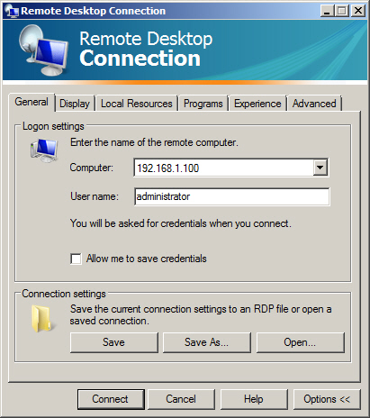

**Domain Name System (DNS):**

* The DNS is a worldwide service that resolves host names to IP addresses.
* This facilitates proper communication between computers. DNS servers communicate with each other in a hierarchy in an effort to teach each other their name resolutions.
* DNS servers use inbound port 53 to accept name resolution request.

**IPSec:**

* Internet Protocol Security is a protocol within the TCP/IP suite that encrypts and authenticates IP packets.
* It is designed to secure any application traffic because it resides on the network layer.
* This protocol is used in conjunction with virtual private networks and is an integral part of IPv6.
* There are three main protocols that IPSec uses to perform its necessary functions:
  + Security association (SA): generates the encryption authentication keys that are used by IPSec.
  + Authentication Header (AH): provides connectionless integrity and the authentication of data. It also provides protection against replay attacks.
  + Encapsulating security payload (ESP): provides the same services as AH but also provides confidentiality when sending data.

**Slide 06: Understanding Wide Area Networks**

**Routing:**

* The process of moving data across networks or internetworks between host or routers themselves.
* Information is transmitted according to the IP networks and individual IP addresses of the hosts in question.
* A router is in charge of maintaining tables of information about other routers on the network or internetwork.

**Routers:**

* Network layer devices.
* A large group of users in a department are usually interconnected using switches within a subnetwork.
* Subnetworks are interconnected using routers so that a user can access other subnetworks or to the external network via the backbone network.

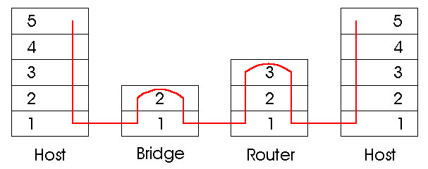

**Campus Network:**